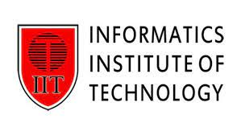
Foundation certificate in higher education

Module – DOC 314 – Digital skills for higher education
Module leader – Mrs. Jananie Mayaroosen
Assessment type – Group course work
Group ID – J – A1

Student ID | Name

Table of Contents
What is computer? 3
Computer generations 4
1st Generation 4
2nd Generation 4
3rd Generation 4

What is computer?

A computer is an electronic device that has revolutionized the way we live and work. It is an incredibly versatile tool that can perform a wide range of tasks, from simple calculations to complex simulations. The basic function of a computer is to process data, which it does using a combination of hardware and software components.

The hardware components of a computer include the central processing unit (CPU), memory, storage devices, input/output devices, and other peripherals. The CPU is the brain of the computer, responsible for executing instructions and performing calculations. Memory allows the computer to temporarily store data and instructions, while storage devices such as hard drives and solid-state drives provide long-term storage for files and programs. Input/output devices such as keyboards, mice, and monitors allow users to interact with the computer and see the results of their actions.

Computer generations

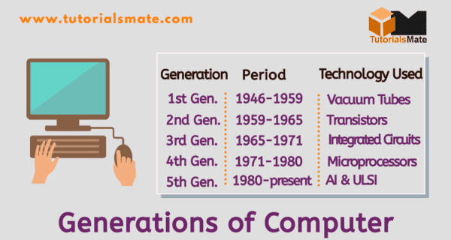

Computers have undergone significant changes since their inception in the mid-20th century. These changes are typically classified into generations, with each generation representing a major leap forward in technology and capabilities. The following is a brief overview of the different computer generations.

1st Generation

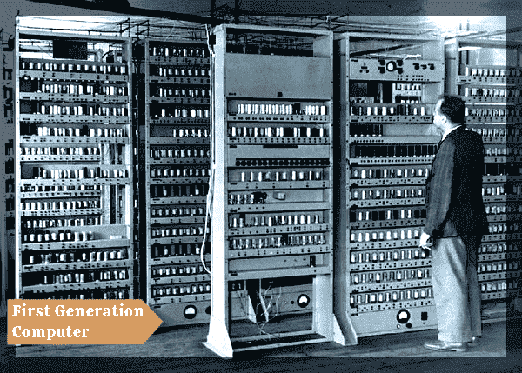

2nd Generation

3rd Generation

4th Generation

